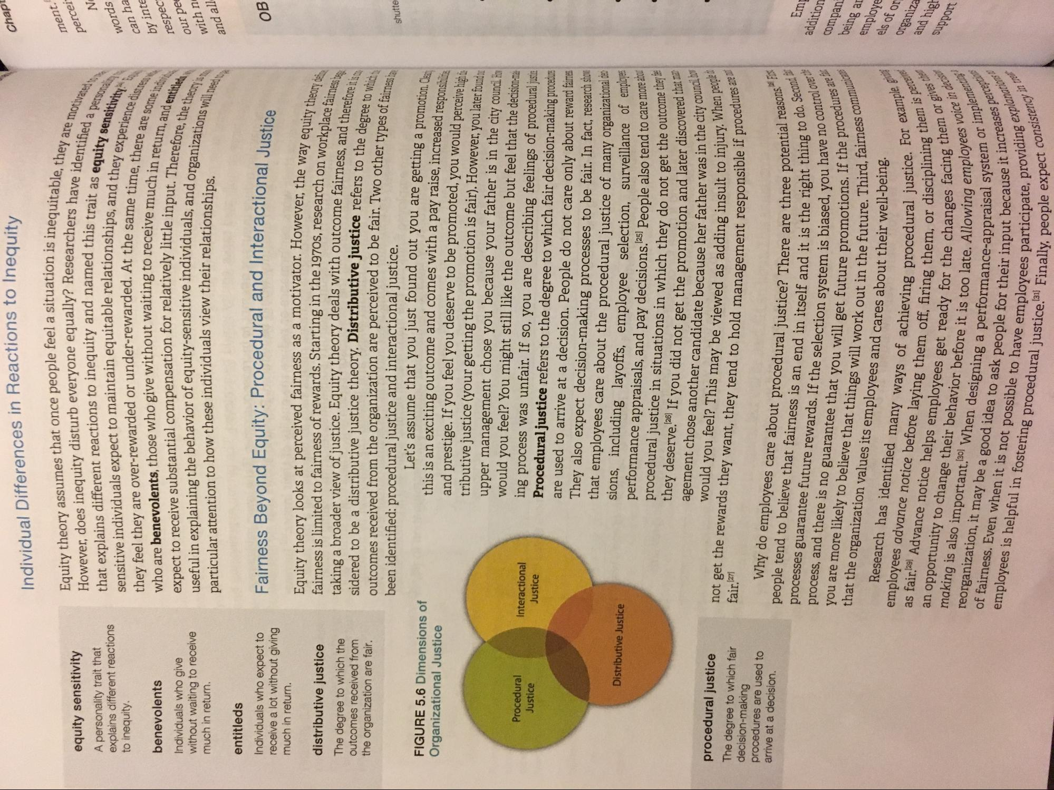
Individual Differences in Reactions to Inequity
Chap
ment. percei
equity sensitivity A personality trait that explains different reactions to inequity.
Equity theory assumes that once people feel a situation is in However, does inequity disturb everyone equally? Researchers h. that explains different reactions to inequity and named this town sensitive individuals expect to maintain equitable relationships a they feel they are over-rewarded or under-rewarded. At the sam who are benevolents, those who give without waiting to receive expect to receive substantial compensation for relatively little inn useful in explaining the behavior of equity-sensitive individuals and particular attention to how these individuals view their relationshire
ISLR
sinequitable, they are motiva
hers have identified a pere this trait as equity sensitivi
hips, and they experience di the same time, there are some receive much in return, anden
ttle input. Therefore, the theo Wals, and organizations will nes
NE words can ha by inte respect our ped with n and all
are some indir
benevolents Individuals who give without waiting to receive much in return.
ов
[ICA
ver the way equity theory des archon workplace fairness has
ness, and therefore it is on ors to the degree to which Two other types of fairness ha
shutte
entitleds Individuals who expect to Fairness Beyond Equity: Procedural and Interactional receive a lot without giving much in return.
Equity theory looks at perceived fairness as a motivator. However then distributive justice
fairness is limited to fairness of rewards. Starting in the 1970s, research onu The degree to which the
taking a broader view of justice. Equity theory deals with outcome fairness and outcomes received from sidered to be a distributive justice theory. Distributive justice refers to then the organization are fair.
outcomes received from the organization are perceived to be fair. Two other tun
been identified: procedural justice and interactional justice. FIGURE 5.6 Dimensions of
Let's assume that you just found out you are getting a promotion Organizational Justice
this is an exciting outcome and comes with a pay raise, increased respondine and prestige. If you feel you deserve to be promoted, you would perceive high a tributive justice (your getting the promotion is fair). However, you later found
upper management chose you because your father is in the city council. Ha Procedural
would you feel? You might still like the outcome but feel that the decision-maki Interactional Justice Justice
ing process was unfair. If so, you are describing feelings of procedural justie Procedural justice refers to the degree to which fair decision-making procedure are used to arrive at a decision. People do not care only about reward fairnes They also expect decision-making processes to be fair. In fact, research show
that employees care about the procedural justice of many organizational Distributive Justice
sions, including layoffs, employee selection, surveillance of empo performance appraisals, and pay decisions. 125) People also tend to care procedural justice in situations in which they do not get the outcom they deserve.26) If you did not get the promotion and later discover
agement chose another candidate because her father was in the procedural justice The degree to which fair
fair.[27]
would you feel? This may be viewed as adding insult to decision-making
not get the rewards they want, they tend to hold management responsible procedures are used to arrive at a decision.
Why do employees care about procedural justice? There are three pos people tend to believe that fairness is an end in itself and it is the right processes guarantee future rewards. If the selection system is biased, you
was in the city council, boy
people
esponsible if procedures are not
ee potential reasons." ER
ght thing to do. Secondo , you have no control over t
ons. If the procedures are ure. Third, fairness communica
addition compan
es and cares about their well-being.
example ginie
procedural justice. For example,
1, or disciplining them is perc
being ar employee els of or organiza and higt
ug them or gives the
process, and there is no guarantee that you will get future promotions you are more likely to believe that things will work out in the future. that the organization values its employees and cares about their we
Research has identified many ways of achieving procedura employees advance notice before laying them off, firing them, o as fair.29) Advance notice helps employees get ready for an opportunity to change their behavior before it is too late. Allow making is also important.30) When designing a performance-app reorganization, it may be a good idea to ask people for their inpu of fairness. Even when it is not possible to have employees employees is helpful in fostering procedural justice. Finally, Pee
ployees get ready for the changes facing the
es voice in decisi
Implementing!
support
e. Allowing employees voice -e-appraisal system or imple
put because it increases per
es perception
pate, providing explanatı
Sistency in treh
lally, people expect consistent

